**Participants:** Monica Council-Miles (BD), Julie Biberstein (Equinix, Inc.), Molly Schuld (Northwestern Mutual), Phil Langford (Northwestern Mutual), Jennifer Brunelle (NRG Energy, Inc.), Kitsy Blanc (PwC, LLP), Janet Rodriguez (PwC LLC), Aditi Trehan (Tata Consultancy Services).

**Guest Speakers:** Felicia Nurmsen, Managing Director of Employer Services, National Organization on Disability (NOD)

**Facilitators**: Jeannine K Brown, Jinny Jeong (CECP), Nandika Madgavkar (CECP), Ella Snow (CECP)

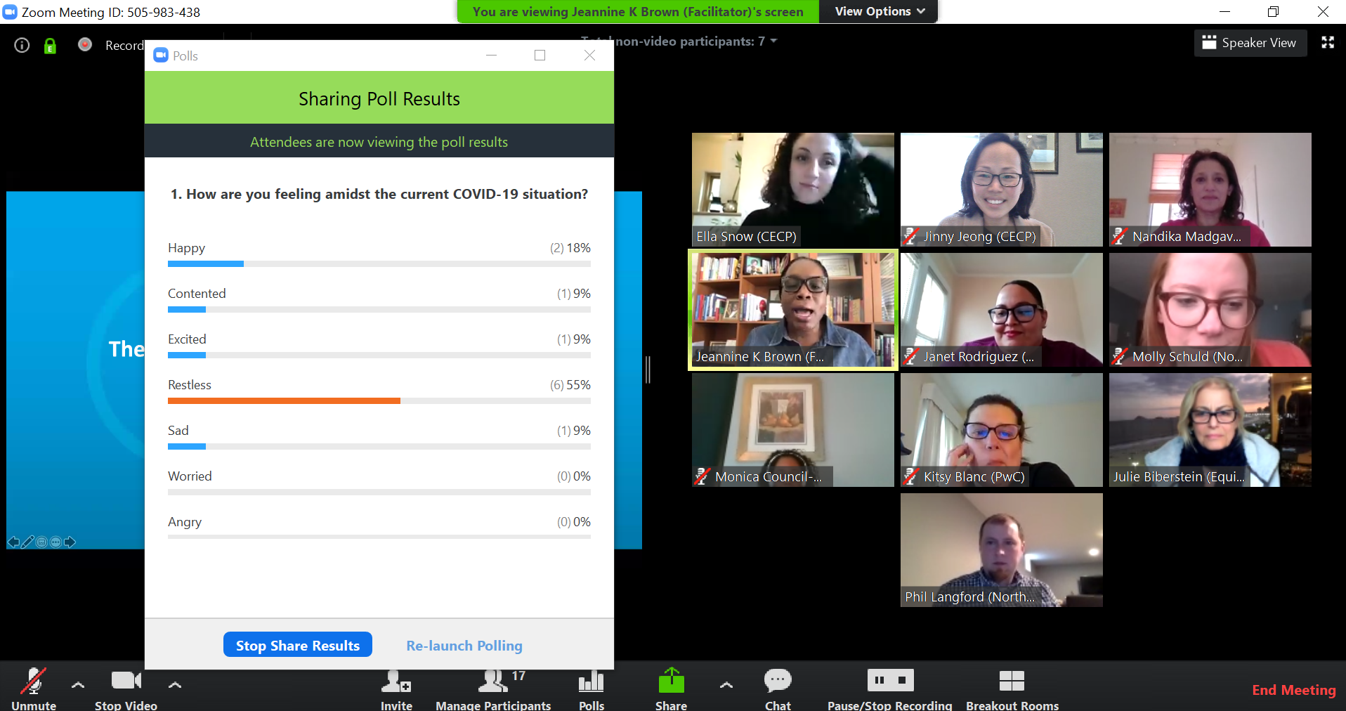

**Summary:**

The group explored the 34 categories of various employment categories and identifiers:

1. Cognitive disability aka Intellectual Functioning
2. Physical abilities and disabilities
3. Mental health
4. Neurodiversity (i.e. Attention Deficit Hyperactivity Disorder)
5. Behavior and ethodiversity
6. Personality and thought-style
7. Cultural background
8. Geographical location
9. Language, linguistical and accents
10. Ethnicity
11. Race
12. Citizenship
13. Age
14. Family and upbringing
15. Ideologies
16. Morals
17. Social role (i.e. gender roles)
18. Gender identity
19. Gender expression (external appearance of an individual’s gender identity)
20. Sex
21. Sexual orientation
22. Education
23. Income
24. Social economic background
25. Life experiences
26. Privilege or social power
27. Marital status
28. Parental status
29. Veterans or Military experience
30. Criminal background
31. Political beliefs
32. Religious & spiritual beliefs
33. Work experiences
34. Skills

There are many ways to remove bias in the interviewing process. They include having inclusive job descriptions, blind resume reviews, structured interviewing and holding consensus debriefs. Details in the grid below. Four best practices were identified for candidate recruitment and selection:

1. **Defining the role and widening the applicant pool** 
   * Focus on the gaps; Specify skills in job postings; Manage experience expectations; Apply lens of intercultural competence (signal a commitment to DEI work)
2. **Sourcing Candidates**
   * Include both short-term and long-term strategies
3. **Narrowing the field**
   * Use a diverse group of reviewers while keeping in mind your candidate pool
4. **Interviewing**
   * Use structured questions; Choose neutral topics for small talk; Default to in-person interviews (if safe to do so, in light of Covid!); Be a good host and be accommodating (find out ahead of time, in a confidential manner, if applicants need accommodation)

|  |  |
| --- | --- |
| **The Role and The Applicant Pool** | |
| **Focus on the internal gaps** | * Ask hiring managers to consider the perspectives and experiences that would add value to their teams. * Add balance, perspective, life experience, and diversity to your talented candidate pool. |
| **Job posting language** | * Avoid using inflexible credentials and minimum qualifications – like educational degrees or certifications as blunt stand-ins for more specific skills. * Be aware that credential proxies may not provide value in and of themselves but are assumed to reflect a set of skills and experience. * Be specific about what skills are actually required, keeping in mind the skills that can be learned on the job. |
| **Manage experience expectations** | * Requiring people to come with experience in perpetuates the lack of diversity. * Identify experience(s) that uses similar skills. * Open the applicant pool to people with relevant experience in private and public sectors. |
| **Seek to fill intercultural competence** | * A commitment to DEI work gives applicants a glimpse into the culture, goals, and expectations of their potential employer. |
| **Diversify group of reviewers** | * Guard against the natural tendency to select candidates like you and like those already employed at the organization. * Include a diverse group of employees in the application review stage. |
| **Know your candidate pool** | * Ensure the pool has sufficient geographic, racial, cultural, gender, and sector diversity If the top candidate pool is homogenous, go back to look at candidates who have shared aspects of their identity that would cause them to be screened out. |

**Highlights from Guest Speaker:**

**Guest Speaker #1: Felicia Nurmsen, Managing Director of Employer Services, National Organization on Disability (NOD)**

**Summary**: It is important to create an inclusive culture in the workplace, keeping in mind that disability lags behind other measures of diversity. Disability can be visible or invisible, so allow candidates and employees to self-identify, which research shows those who do are happier and more productive. There is power in language: instead of saying “accommodations”, better phrase is ‘productivity tools’. It is important for managers to know their company’s accommodation policies and processes since 99% of applicants with disabilities will approach hiring managers, not HR. Companies are encourage to review the following resource, a seven-step guide to how companies can build a more inclusive culture: [www.NOD.org/lookcloser](http://www.NOD.org/lookcloser).

**Best Practices:**

* Include diversity in D&I statement and any other company **materials**, and include images.
* When considering the candidate, **focus on the skills and knowledge**, not the disability
* Include in **job descriptions** which specify and distinguish essentials functions vs marginal functions.
* **Ask about accommodations, adjustments, or support needed during the ENTIRE process** and make sure there is a consistency of communicating it – from the process of applying, interviewing, onboarding, etc.
  + People do not have to disclose their needed accommodations prior to being hired, and employers are responsible for making those accommodations available whenever they are disclosed.
  + Keep in mind they may not need accommodations until they are hired.
  + Accommodations may also come in the form of their role as a parent or caretaker, not for themselves directly.
  + Be mindful of how employees might indirectly ask for accommodations, and be sure that the reaction is “**How can I help?**”
* For interviews, **review interview location** to make sure it’s accessible – this includes looking at parking, entrance, etc.
* When onboarding new employees with disabilities, clearly explain all expectations and requirements of roles. Providing an **employee buddy/mentorship volunteer program** has shown to be successful.
* In retaining and advancing employees with disabilities, employers should be creative with “typical” activities (i.e. networking happy hours) to ensure inclusivity/accessibility for all employees.

**Additional Reading Materials & Resources for Meeting #3:**

1. **Disability Inclusion Roadmap**: a seven-step guide to building a more inclusive culture by the National Organization on Disability (NOD). A guide to help you learn more about disability inclusion and how your company can Look Closer at America’s largest untapped talent pool: [www.NOD.org/lookcloser](http://www.NOD.org/lookcloser).
2. **Women In The Workplace: 2019**: A five-year lookback on the data collected by McKinsey in 2015 from 600 companies and employees on their workplace experiences, and more than 100 in-depth one-on-one interviews: [https://www.mckinsey.com/featured-insights/gender-equality/women-in-the-workplace-2019#](https://www.mckinsey.com/featured-insights/gender-equality/women-in-the-workplace-2019)
3. **Being Black in Corporate America: An Intersectional Exploration:** A research by Center for Talent Innovation on what it is like to be Black at work, and best practices on how employers can build more equitable, inclusive cultures for Black professionals: <https://www.talentinnovation.org/_private/assets/BeingBlack-KeyFindings-CTI.pdf>