**Participants:** Sujata Narayan (Equinix, Inc.), Irissol Arce (Northwestern Mutual), Jennifer Brunelle (NRG Energy, Inc.), Aditi Trehan (Tata Consultancy Services), Kitsy Blanc (PwC, LLP), Monica Council-Miles (BD), Johnel Evans (BD)

**Guest Speakers:** Trella Walker (NFF), Jackie Berry (3M)

**Facilitators**: Jeannine K Brown, Jinny Jeong (CECP), Nandika Madgavkar (CECP), Ella Snow (CECP)

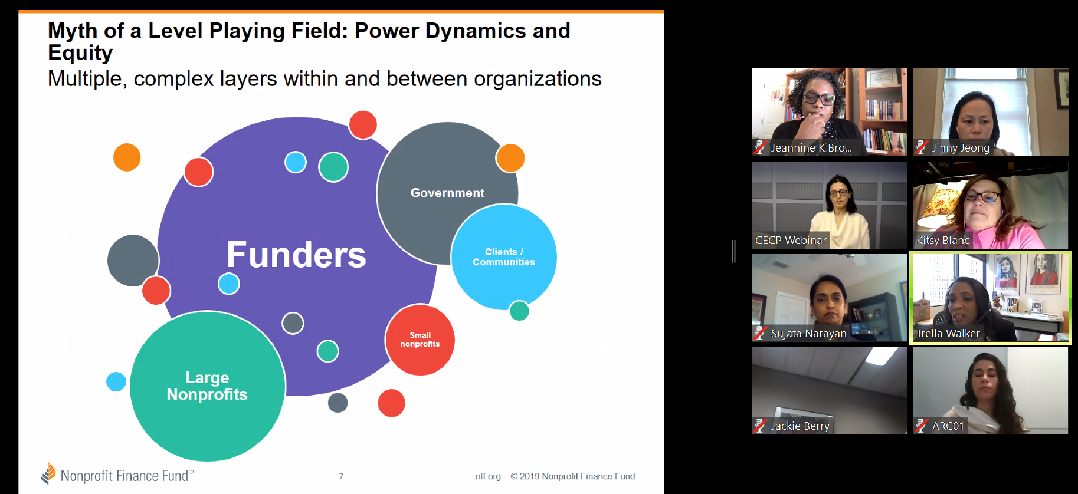

**Summary:**

The philanthropic giving and grantmaking with a lens of equity framework is a proactive, strategic approach to improving the outcomes that accounts for structural differences in opportunities, burdens and needs in order to advance targeted solution that fulfill the promise of true equity for all. Equity is achieved when an advantage or disadvantage can no longer be predicted based on race, ethnicity, gender, gender identity, sexual orientation or ability. Philanthropists and grant makers seek to create sustainable change by solving problems rather than providing funds to support people facing the problems.

The following areas of the grantmaking process have unconscious or built-in bias that impedes on the organization’s ability to achieve equity.

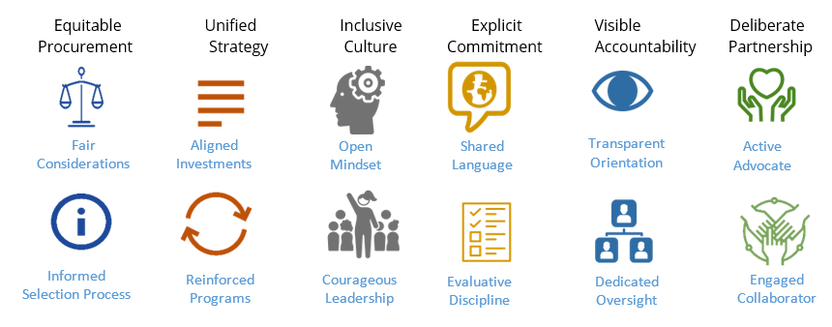

**Top barriers faced in the funding process:**

* **Systemic and outdated structural issues in the process**

**Problem**: Funders are limited by their own rules, regulation, requirements and definitions.

**Solution:** Ask questions about the process flow for objectivity and continuous improvement.

* **Reporting requirements**

**Problem**: The application reporting requirements are not commensurate with the grant size.

**Solution:** Make the administration commensurate with the grant size. For example, a $5,000 grant should come with different reporting expectations than a $500,000 one.

* **No or little experience of the applicant**

**Problem:** The “letter of intent” stage that precedes the proposal can be biased. The applicant may not have the necessary experience or the training to write the proposal in the exact manner the grantor likes. The project is not awarded - not because the project lacks value, but because the applicant lacks know-how.

**Solution:** Consider additional process to capture information about the project before and during the application process such as, Q&A conference calls, site visits, narrative examples, etc.

* **The usual suspects**

**Problem:** Funders seek to validate grantees using trusted sources or rating systems. If those trusted organizations are demographically similar, racially similar, and from an ethnicity point of view also very similar, they are the same networks.

**Solutions**: Expand the networks from which you seek applicants. Find new ways to target organizations who may not be aware of your application. Diversify your portfolio.

* **Talent pipeline**

**Problem:** The proportion of philanthropic positions held by underrepresented groups remains low

**Solution:** Establish a community advisory boardto address the built-in lack of voice for marginalized communities that can result in an understanding gap around important social problems that affect those communities.

“If you don’t understand the barriers, both historic and current, a neighborhood faces on a daily basis,

it’s difficult to serve those neighborhoods effectively,”

Sidney Hargro, President, Philanthropy Network Greater Philadelphia

**Highlights from Guest Speakers:**

**Guest Speaker #1: Trella Walker, Associate Director- Advisory Services, Nonprofit Finance Fund**

* NFF Toolkit: [*Addressing Racially Biased Financial Analysis*](https://nff.org/fundamental/addressing-racially-biased-financial-analysis)
* List of 7 Steps: [*What can funders do to champion funding equity and inclusion in their grantmaking?*](https://nff.org/commentary/nonprofit-resource-equity-and-access-call-close-gap)
* Steps to Racial Equality:[*https://www.philanthropy.com/article/Color-Blind-Assessments-of/247431*](https://www.philanthropy.com/article/Color-Blind-Assessments-of/247431)

Below is a summary of the Nonprofit Finance Fund’s Examining Racially Biased Financial Analysis Toolkit.

* “As funders I think we need to pay for the type of reporting that we are asking for. We are creating a greater expense for smaller organizations.”
* Organizations with the smallest budgets have the largest impact, but they are discounted and over-looked
* This toolkit helps organizations to bridge that knowledge/financial gap

| **Blind spot** | **Inequity Exacerbated** | **Addressing Inequity** |
| --- | --- | --- |
| Whose board gives | Underestimating the support that some organizations without wealthy board members have from its community and over-estimating the community engagement of others. | Count board commitment in other ways and count community engagement beyond the board with similar focus on total value, rather than money donated. |
| Who can afford below cost contracts and grants | Orgs with connections to private donors can take this on and the revenue that comes with it; those without connections and the ability to invest in more fundraising cannot. | Cover full costs. There is no way to be equitable without that. Help grantees understand and advocate for full-cost coverage from contracts and grants. |
| Who can benefit from matching grants | Matching grants steer funding toward organizations already able to find the match. | Do not make funding contingent on securing a match. Find other ways to motivate additional giving by offering to connect grantees to other donors. |
| Minimum revenue required to secure some grants keep small organizations small. | Orgs without community financial wealth have harder time raising individual donations and managing “revenue risk,” as well as being “stable” enough for institutional funding. This leaves important, community organizations vulnerable. | Don’t apply revenue size and composition blindly as a hallmark of financial health. Consider history of org and access. Provide funding for small orgs to build their capacity to manage larger contracts, and then set aside some money to fund smaller orgs with larger grants. |
| Funders associate small organizations with community authenticity | Small, community-based organizations stay small and disconnected from larger donors with minimum-size rules. | Assess proposals based on the org’s potential to do the work, not its historic revenues; for larger funders, explicitly carve out some funding for smaller orgs to invest in their capacity to compete for and win larger grants. |
| Salaries can be much lower than the market value of the services being provided | Low salary signals to funders a lack of skill and experience or lack of financial savvy among the potential grantee’s leadership, making it harder to secure a grant, and reducing the grant size once secured if it is pegged to day rates of salary being paid. | Understand the value of the work being performed under a grant and provide larger grants to cover a reasonable rate for securing these services. Do not make funding rules that pay differential rates for the same work based on an org’s historic budget size. |
| Only certain volunteers count financially | If grant size is pegged to a set percentage of an organization’s revenue, or general view of its “size,” then the organization better-connected to credentialed professional volunteers will be eligible for larger grants. | Don’t rely on set ratios that limit grants to a certain share of total revenue without adjusting for context. Take the time to understand all the resources the org mobilizes. |
| Endowment existence/size | Funders who consider an endowment a marker of success may not give to the community center, despite its efficacy serving its community and its resulting popularity. | Don’t use the existence of an endowment or lack as a consideration for funding. Find other ways to measure community support. |

**Guest Speaker #2: Jackie Berry, Manager, Education Initiatives, 3M**

* Strategy re-fresh occurred a few years ago when the staff and Board recognized that it was difficult to tell the story of what 3M’s focus areas were and what they supported.
* 3M’s focus today is on creating a pipeline for careers in STEM starting with educational programs in the Minneapolis school system (early K-12, or “K to Career” STEM)
* They have targeted colleges to expose underrepresented groups to higher education and careers in STEM, and currently support non-tenured faculty of color in universities. This is because there is the problem of the ‘leaking STEM pipeline’ – not enough are reaching to, and pursuing, careers. And for those that do, there are not enough teachers of color and diversity on that level.
* They also focus on “science-encouragement programs”, not just raising awareness.
* 3M created a ‘strategic roadmap’ and uses a matrix to captures application questions and answers (the goal is to ensure giving and partnership aligns to 3Mgives and 3M Foundation):
  + Commitment to equity, diversity, and inclusion through mission, demographics of end-recipients, and program investments ($)
  + Financial health of organization and/or program
  + Examples of evidence-based approach in discussion of programs and results
  + Level of 3M employee engagement with the organization

**Additional Reading Materials & Resources for Meeting #2:**

1. “Incorporating Diversity, Equity, and Inclusion in Your Grant-Making Process: A List of Potential Actions”. By Arabella Advisors: A **checklist** that grant-making organizations can use to incorporate DEI into their grant making.  <https://www.arabellaadvisors.com/wp-content/uploads/2019/06/DEI_Grant_Making.pdf>
2. “Grantmaking with a Racial Equity Lens”. By GrantCraft (Foundation Center), in partnership with Philanthropic Initiative for Racial Equity (PRE): A **guide** that offers advice on promoting and deepening your foundation’s commitment to racial equity, both internally and in the programs you support. <http://grantcraft.org/wp-content/uploads/sites/2/2018/12/equity.pdf>
3. Recently released film **“Just Mercy”** by Bryan Stevenson, Participant Media. A powerful film that tells the story of [Equal Justice Initiative (EJI)](https://eji.org/). Out in theaters Dec 25th, you can check for local listings here: <https://www.shorturl.at/uAV56>. There are also opportunities to host a private screening for employees with a facilitated discussion led by the production company until the end of February 2020 (interest form [here](https://docs.google.com/forms/d/e/1FAIpQLScHzPuL9qFv-71xgtNT_-G42drEbVBKJqwiE9S5Y3-jVI1kLA/viewform); CECP can also share more information).